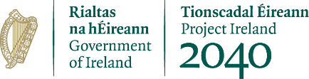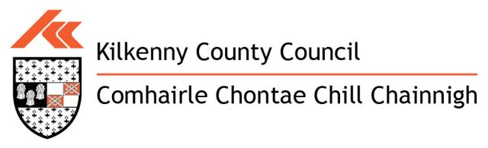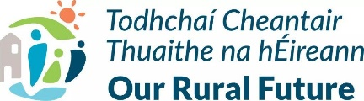
KILKENNY COUNTY COUNCIL
CLÁR 2023 Scheme Outline

CLÁR (Ceantair Laga Árd-Riachtanais) is a targeted investment programme for rural areas that aims to provide funding for small infrastructural projects in areas that have experienced significant levels of de-population.
The CLÁR 2023 programme will be delivered through 3 separate Measures as follows:
Measure 1. Developing Community Facilities & Amenities
Measure 2. Mobility, Cancer Care and Community First Responders Transport
Measure 3. ‘Our Islands’
Measure 1 is administered through Kilkenny County Council, and can be applied for by Kilkenny County Council in conjunction with groups in Local Communities. Measure 2 and Measure 3 is being administered through the Department of Rural & Community Development.
Kilkenny County Council is pleased to announce that it is seeking applications for the CLÁR 2023 funding scheme from Community Groups. Measure 1 will support a variety of capital interventions that contribute to the enhancement of existing, and/or the development of new, accessible Community Recreation Facilities. The list below provides an indication of the types of interventions that may be supported, but is not exhaustive:-
- Multi-Use Gaming Areas MUGAs)/Astro-Turf Facilities
- Skateboard Parks/Cycling Tracks
- Playgrounds
- Handball Alleys
- Tennis Courts
- Basketball Courts
- Community Gyms
- Community Cinemas
- Sensory Gardens
- Community Gardens
- Outdoor Bowling areas
- Walking/Running Tracks
- Outdoor Toilet Facilities
- Car Parking
- Public Lighting
For the first time under the CLÁR Programme, funding will be provided to carry out upgrades and improvements to spectator stands at local GAA and sports clubs.
Measure 1 applications can also include small scale renovation works to community facilities e.g. floors, windows, doors, heating upgrades, kitchen upgrades) and in particular community centres that did not receive funding under the Communities Centres Investment Fund (CCIF).
All community amenities funder under this programme must, in so far as practicable, be accessible to all abilities and ages.
Grant Aid
A minimum grant of €5,000 and a maximum grant of €50,000 for projects will be available. The maximum grant payable will be 90% of the project cost or a maximum of €50,000, whichever is the lesser. The remaining 10% or balance of the cost should be provided through local authority/community/other resources with a minimum of 5% cash contribution from the Community. Philanthropic contributions may be accepted as full or part of match funding costs.
CLÁR Eligible Electoral Districts
Coolaghmore | Tullahought | Jerpoint West | Balleen
Killamery | Attanagh | Listerlin | Ballyconra
Kilmaganny | Clogharinka | Tiscoffin | Baunmore
Kilmanagh | Kilmacar | Castlebanny | Clomantagh
Scotsborough | Mothell | Castlegannon | Galmoy
Boolyglass | Muckalee | Kilkeasy | Glashare
Muckalee | Brownsford | Pleberstown | Lisdowney
Tubbrid | Dysartmoon | Ullard

Application Forms and further particulars may be downloaded from www.kilkennycoco.ie or Cora Nolan, Community Section, Johns Green, Tel: 056-7794931.
Completed applications are to be sent to Kilkenny County Council’s Community Department, John’s Green House, Kilkenny by 4pm, 24th May, 2023.
All intended applicants should make contact with Catherine Byrne-Murphy 056-7794115, prior to the submission of their applications.

