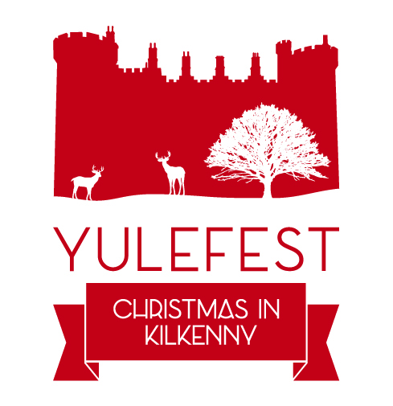
YULEFEST 2021 COMMUNITY ENHANCEMENT FUNDING SCHEME
Yulefest - Christmas in Kilkenny 2021 is offering grant-aid to enable towns and villages in the Municipal Districts of Kilkenny to enhance the 2021 Christmas experience for everyone in their area. Applications can only be submitted by established local community groups. Individuals cannot apply.
The funding is available to community organisations to dress and light your town or village or create an outdoor public Christmas experiences or events which would be accessible and applicable to all of the community for example;
- Dressing towns and villages for Christmas in a sustainable, environmentally friendly way.
- Creating / Lighting /Decorating a specific area in the community with a Yulefest ‘Christmas in Kilkenny’ theme;
- Organising a Christmas event which engages local performers e.g. Choral/music performances;
- Organising ‘green’ environmental Christmas activities - e.g community Christmas cycle, walk, trail etc.
Preference is given to applications which are aligned with the ethos of Yulefest, that of inclusivity, participation and engagement across the entire community.
NOTE
This scheme for all county towns and villages in Kilkenny municipal districts and has a total fund of €8,000. Eligible expenditure will be subject to maximum 75% funding.
Only one application per town or village will be approved, therefore communities are asked to coordinate a single application from their town or village.
Please submit completed Grant Applications to events@yulefestkilkenny.ie
Closing date: Friday 19th November 2021.

YULEFEST 2021 - COMMUNITY GROUP APPLICATION FORM
All sections must be fully completed
Name of Organisation/s
Address:
Contact Person:
Position in Organisation:
Contact Number:
Email:
Are you collaborating with any other local groups?
If yes, which groups?
Your Municipal District | MD North (Castlecomer)
 | MD South (Piltown)
 | MD City East (Callan/Thomastown)
Details of previous funding received from Yulefest:
Please describe your proposal and outline how it will impact the experience of Christmas in your community.

How many people will benefit from this proposal?
Please list all the costs associated with this application (including VAT)
Total Cost including VAT
% Funding Sought:
Own funding source:
Have you sought other funding (PPN LEADER etc) for this proposal
If you, pleas provide details:

ACKNOWLEDGEMENT – ON BEHALF OF YOUR GROUP
- We confirm that the information provided is accurate and agree to comply with the terms of the scheme.
- We confirm that we will acknowledge Yulefest and Kilkenny County Council’s support and include Yulefest’s logo and Kilkenny County Council’s logo in all publicity.
- We agree that if our application is successful we will work with Yulefest to jointly promote all events.
- We understand that grant aid cannot be drawn down until paid invoicesare submitted and approved and it will be paid for eligible expenditure only.

Signature:
Date:
On behalf of:

