Kilkenny Public Participation Network supports community groups with small once off projects that have a social inclusion remit and work towards the inclusion of those outlined in the Equal Status Acts 2000-2004 as well as other identifiable socially excluded groups. These acts prohibit discrimination and include nine grounds as follows:
- gender;
- marital status
- family status
- sexual orientation
- religious belief
- age
- disability
- race
- membership of the Traveller community.

While not a funding body, the PPN may on occasion have discretionary monies to support small projects. The smallest grant can be as small as €100 up to a maximum of €400. The budget is small and limited and is based on a first come first served basis.

What will be funded:
- Arts-based/cultural/sporting or training initiatives that promotes awareness of the target group or promotes integration and links into an existing festival or event in Kilkenny – promotes participation
- A public event/ awareness raising programme that celebrates or highlights some aspect of the groups identity– or a number of identities where groups come together
- A training event/programme that encourages participation and fosters inclusion
- An initiative that promotes participation in the local fabric of society/ cultural experience within the community

Criteria for funding:
- Your event must have a community focus/benefit and it must be free of charge or costs involved must not be used for personal profit
- Training must have a social inclusion element i.e. benefit a particular group/cohort in society
- Groups must have a recognised organisation name and bank/credit union account or have a recognised mentor or parent group (with a bank/ credit union account) to administer funding on their behalf
- A short report outlining how the funding was spent and the outcome of the event must be submitted not later than one month after the event has taken place. Photographs can also be included.
- Kilkenny PPN logos should be used on any promotional material relating to the event. With the heading: This event is supported by Kilkenny PPPN as part of the social inclusion pillar.

Process for approval of applications:
All applications will be accessed by the PPN Resource Worker and 2 members of the Community & Culture Department staff of Kilkenny County Council. Notification will be immediate or within 2 weeks at the latest.

Applications must be submitted before the date of the programme/event

PART 1 – Your Organisation

- Name of the organisation or group_____________________________________

- Address of the organisation ___________________________________________
- Main phone number of the organisation ________________________________
- What are the main activities of your organisation? Maximum 50 words please. (i.e., aims, target group, type of activities)
__________________________________________________________________________________________________________________________________________________________________________________________________________________________________________________________________________________________________________________________________________________________________________________________________________________________________________________________________________________________________________________________________________________________________________________________________________________________________________________________________________________________________________________

- Has your organisation received sponsorship from Kilkenny PPN before?

If yes, please provide brief details ________________________________________________________________________________________________________________________________________________________________________________________________________________________________________________________________________

- Does your group have a bank account? ______________________________

PART 2 - Applicant Details (details of the person who is applying for the grant)

- Name of applicant ________________________________________________
- Position within the organisation _____________________________________
- Correspondence address (if different from that of the organisation)
______________________________________________________________
- Applicant’s contact email address ______________________________________________________________________________________________________________________________
- Daytime phone number ___________________________________________
- Mobile phone number ____________________________________________

PART 3 – Your Project
- Please describe the specific programme /event for which you are applying for a grant (Maximum 50 words please)
____________________________________________________________________________________________________________________________________________________________________________________________________________________________________________________________________________________________________________________________________________________________________________________________________________________________________________________________________________________________________________________________________________________________________________________________________________________________________________________________________________________________________________________________________________________________________________________________________________________________________________________________

- Please provide a breakdown of the costs for this specific programme/event, i.e., what are you asking us to fund with the grant?

Event/activity/ materials | How much will this cost

TOTAL COST: ________________________________________________

- How much are you applying for? (Maximum funding is €400) _________________________________________________________________

- Please name any other sources of funding you have for this programme/event: ____________________________________________________________________________________________________________________________________
- When will this programme/event begin? _________________________________________

- When will this programme/event be completed?

_________________________________________

Please return by close of business Monday 21st to:

Mags Whelan
Co-ordinator
Kilkenny Public Participation Network (PPN)
42 Parliament St
Kilkenny
Tel: 056 779 4710
Mobile: 087 173 1634
E-mail: ppnkilkenny@kilkennycoco.ie
Website: www.kilkennyppn.ie

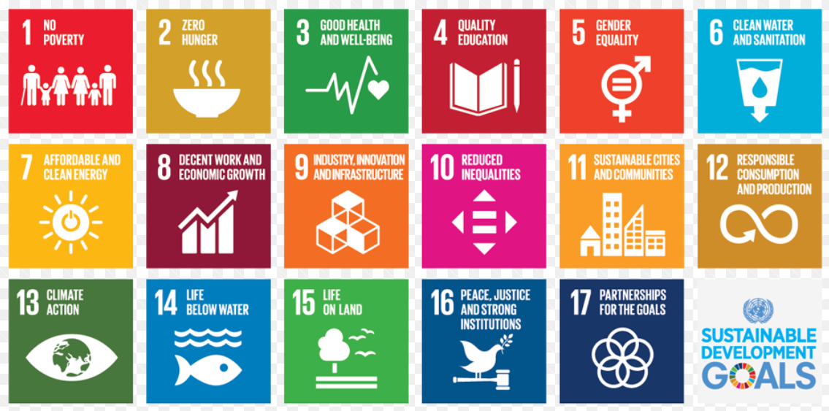

Kilkenny PPN encourages groups/organisations to find practical ways to incorporate the Sustainable Development Goals (SDG’s) into your communities

